Week 5 Internship Documentation
Infosys Springboard Internship | Data Visualization Domain
Topic Focus: ETL Process, Detailed EDA, Missing Value Analysis, and Outlier Detection
Prepared by: Hindu Priya Boddu
Project: Optimizing IT Support Team Performance Using Analytics


1. Introduction
During Week 5 of the internship, the focus moved to a more advanced and professional stage of data analysis by studying ETL (Extract, Transform, Load) and EDA (Exploratory Data Analysis) in detail. This week was highly important because it helped in understanding how raw data becomes analysis-ready and how the dataset can be explored deeply before final dashboard creation. The learning covered ETL from basic to advanced level, detailed EDA methods, missing value analysis, outlier detection, and visualization of empty versus filled values in the dataset.
For the project 'Optimizing IT Support Team Performance Using Analytics,' this week is critical because accurate insights depend on a strong ETL process and thorough exploratory analysis. EDA helps identify patterns, anomalies, trends, and hidden relationships in the support ticket data, while ETL ensures that the data is properly prepared and loaded into Power BI for reliable reporting.

2. ETL (Extract, Transform, Load) – From Basic to Pro Level
ETL is a foundational process in data analytics, business intelligence, and data engineering. It refers to the structured pipeline through which raw data is collected, cleaned, transformed, and loaded into a system where it can be analyzed. In Power BI projects, ETL is usually performed using Power Query.
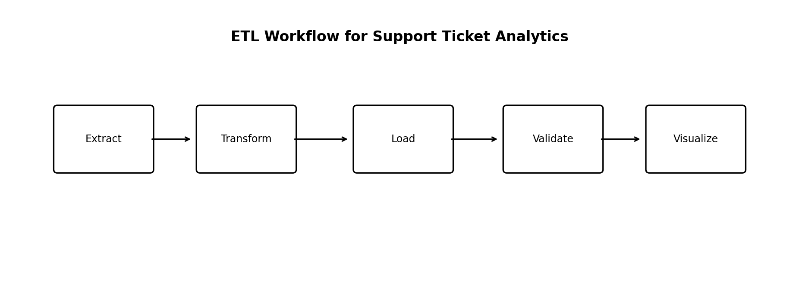
Figure 1: ETL workflow for the support ticket analytics project

2.1 Extract
Extract means collecting data from one or more sources. In this project, the source is the support ticket dataset, which can be imported from CSV, Excel, database, or web source. The extraction step is not only about loading the file; it also involves understanding the source structure, checking headers, identifying delimiters, and confirming whether the raw file contains clean tabular data.
- Possible source types: CSV, Excel, database, web, or folder
- Check if the first row contains headers
- Verify delimiter and encoding in CSV files
- Inspect if the source contains merged cells, extra blank rows, or metadata

2.2 Transform
Transform is the most important stage in Power BI ETL. In this stage, raw data is converted into clean, structured, and business-ready data. For the support ticket dataset, transformation includes changing data types, removing duplicates, handling null values, standardizing text, validating dates, replacing 'N/A' values, and ensuring consistency in status, priority, and SLA fields.
- Change data types correctly
- Remove duplicates using ticket_id
- Standardize text values such as priority, status, channel, and region
- Handle null values carefully based on business meaning
- Replace browser value 'N/A' with 'Unknown'
- Trim and clean text fields
- Validate date fields and duration metrics

2.3 Load
Load means sending the transformed dataset into the Power BI data model for reporting and visualization. At this stage, only clean and validated data should be loaded. The quality of the load stage directly affects the reliability of DAX measures, visuals, filters, and dashboard performance.
- Load only required columns to reduce model size
- Avoid unnecessary text-heavy columns if not needed in visuals
- Keep primary analysis columns ready for DAX and slicing
- Validate row count before and after load

2.4 Pro-Level ETL Practices
- Use meaningful applied steps in Power Query
- Remove unnecessary columns early for performance optimization
- Create a reusable and repeatable transformation pipeline
- Validate business rules such as Closed tickets should have resolved dates
- Separate raw data and processed data versions
- Document all major transformations for auditability

3. EDA (Exploratory Data Analysis) – Detailed Understanding
EDA is the process of exploring the dataset before final modeling or dashboard development. It helps in understanding the shape, structure, distributions, relationships, missing values, outliers, and possible business insights. EDA is one of the most important parts of an analytics project because it helps analysts ask the right questions before building visuals.
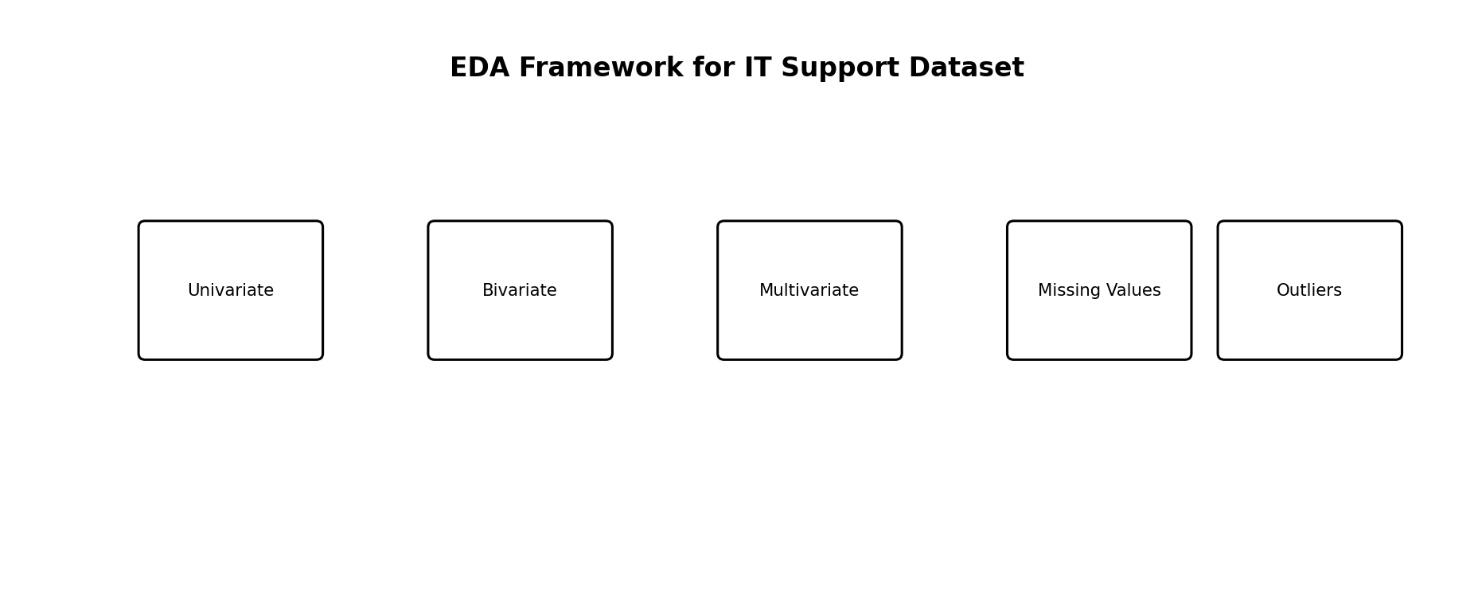
Figure 2: EDA framework applied to the support ticket dataset

3.1 Objectives of EDA in This Project
- Understand ticket volume and category distribution
- Identify which products and channels generate more tickets
- Study response and resolution time distributions
- Check missing values and data quality issues
- Detect outliers in numeric columns
- Understand how satisfaction is related to time metrics
- Identify business patterns by priority, region, and customer segment

4. Types of EDA and Their Use in This Dataset

4.1 Univariate Analysis
Univariate analysis focuses on examining a single variable at a time to understand its distribution and characteristics.

Use in This Dataset:
- Analyzed individual score columns such as Math Score, Reading Score, and Writing Score.
- Observed average performance levels of students.
- Checked distribution of categorical variables like Gender and Test Preparation status.
Purpose:
- Understand overall performance trends.
- Identify basic patterns in each variable independently.
Example from Dashboard:
- KPI Cards showing average subject scores.
- Pie/Donut charts showing gender or preparation distribution.

4.2 Bivariate Analysis
Bivariate analysis studies the relationship between two variables to identify comparisons or correlations.

Use in This Dataset:
- Compared Gender vs Average Scores.
- Compared Test Preparation vs Student Performance.
- Examined Parental Education vs Academic Results.
Purpose:
- Identify factors influencing student performance.
- Detect performance differences between categories.
Example from Dashboard:
- Gender comparison charts.
- Test preparation performance visuals.

4.3 Multivariate Analysis
Multivariate analysis studies more than two variables together. In Power BI, this is often achieved through matrices, scatter plots with legends, drill-down visuals, and filtered analysis.
Use in This Dataset:
- Analyzed how Ethnicity and Parental Education together influence scores.
- Explored combined effects of demographic factors on performance.
Purpose:
- Gain deeper insights into multiple influencing factors.
- Understand complex performance patterns.
Example from Dashboard:
- Combined charts comparing ethnicity with parental education levels.

5. Detailed EDA Functions and Their Use in This Dataset
Exploratory Data Analysis (EDA) involves applying various data exploration and transformation functions to understand dataset characteristics before visualization and analysis. In the Student Performance Analysis Dataset, several EDA functions were used in Power BI to clean, organize, and analyze the data effectively.
These functions helped ensure data accuracy, consistency, and meaningful interpretation of student performance trends.

1. Data Type Validation
Function Used: Change Data Type (Power Query)
Purpose:
To ensure each column contains the correct type of data for analysis.
Use in Dataset:
- Student ID set as text/identifier.
- Math, Reading, and Writing scores converted to numeric values.
- Gender, Ethnicity, and Parental Education treated as categorical fields.
Benefit:
Prevents calculation errors and enables accurate aggregations.

2. Trim Function
Function Used: Transform → Format → Trim
Purpose:
Removes extra spaces before and after text values.
Use in Dataset:
- Cleaned categorical columns such as Gender and Parental Education.
Benefit:
Avoids duplicate categories caused by hidden spaces.

3. Replace Values
Function Used: Home → Replace Values
Purpose:
Standardizes inconsistent data entries.
Use in Dataset:
- Corrected inconsistent naming formats.
- Standardized category labels for better grouping.
Benefit:
Improves data consistency and visualization accuracy.

4. Remove Duplicates (Validation Step)
Function Used: Remove Rows → Remove Duplicates
Purpose:
Ensures each student record is unique.
Use in Dataset:
- Verified that Student ID represents a unique entry.
Benefit:
Prevents incorrect aggregation results.

5. Handling Missing Values
Function Used: Filter / Data Validation
Purpose:
Identify and manage null or missing records.
Use in Dataset:
- Checked for empty score values.
- Ensured all students had valid performance data.
Benefit:
Maintains reliability of analysis results.

6. Aggregation Functions
Functions Used: Average, Count
Purpose:
Summarizes large datasets into meaningful metrics.
Use in Dataset:
- Calculated average Math, Reading, and Writing scores.
- Counted total number of students.
Benefit:
Provides quick performance overview through KPIs.

7. Calculated Measures (DAX)
Functions Used: AVERAGE(), COUNT(), DIVIDE()
Purpose:
Create analytical metrics for dashboard insights.
Use in Dataset:
- Calculated overall average performance score.
- Generated performance comparison measures.
Benefit:
Supports dynamic and interactive dashboard analysis.

8. Filtering and Grouping
Function Used: Slicers and Filters
Purpose:
Allows dynamic data exploration.
Use in Dataset:
- Filtered results by Gender, Ethnicity, Parental Education, and Test Preparation.
Benefit:
Enables users to analyze customized scenarios interactively.

Conclusion
The application of EDA functions ensured that the dataset was clean, structured, and analysis-ready. These preprocessing and analytical steps improved data quality and enabled accurate visualization of student performance patterns within the dashboard.

6. Missing Value Analysis (Empty vs Filled Values)
One of the important extra topics in Week 5 is analyzing missing values. Missing values can strongly affect KPIs, averages, filters, and charts. Therefore, before final dashboard creation, each column should be checked for empty (null / blank) and filled values.
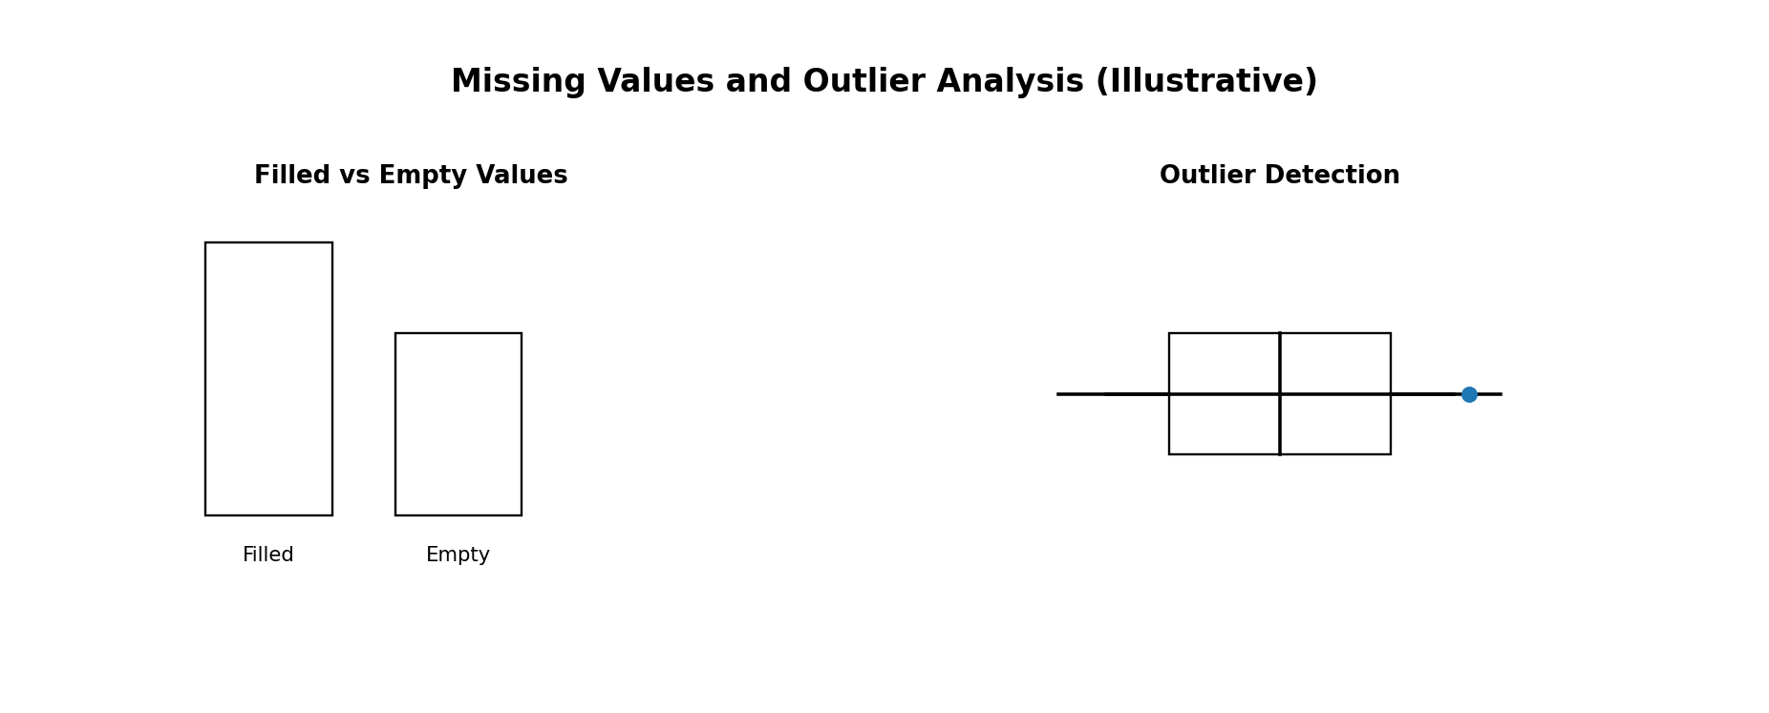
Figure 3: Illustrative representation of filled vs empty values and outlier analysis

6.1 Why Visualize Empty and Filled Values?
- To identify which columns are incomplete
- To measure data completeness before KPI creation
- To decide whether nulls should be removed, replaced, or retained
- To detect columns that may not be reliable for analysis

6.2How to Visualize in Power BI
- Use Column Quality in Power Query (Valid / Error / Empty)
- Create a custom completeness table showing filled and blank counts
- Use stacked bar chart: Filled vs Empty by Column
- Use matrix table for missing percentage by important fields

7. Outlier Analysis
Outliers are unusually high or low values that differ significantly from the rest of the data. In this support ticket dataset, outliers are especially important in columns such as first_response_time_hours, resolution_time_hours, previous_tickets, customer_tenure_months, and issue_complexity_score.

7.1 Why Outliers Matter
- Can distort averages and KPI cards
- Can make normal performance look worse or better than reality
- Can indicate data entry errors
- Can also represent real but critical business cases

7.2 Common Outlier Detection Methods
- Box plot method (IQR based)
- Z-score method (statistical)
- Min/Max business rule validation
- Visual inspection through sorted tables and histograms

7.3 Recommended Handling of Outliers
- Do not remove outliers blindly
- First validate whether the outlier is a data error or a real business case
- If it is a valid extreme ticket, keep it and analyze separately
- Use median-based KPIs when averages are heavily distorted
- Create a flag column for outlier cases if necessary

8. Applying EDA and ETL to the Student perfomance Analysis Dataset
- Data Collection
The student performance dataset was imported into Power BI from the source file for analysis and visualization.
- Data Extraction (ETL – Extract Phase)
Relevant columns such as Student ID, Gender, Ethnicity, Parental Education, Test Preparation, and subject scores were extracted for further processing.
- Data Cleaning
Unnecessary spaces and inconsistent text values were removed using the Trim and Replace Values functions to ensure uniform data formatting.
- Data Type Transformation (ETL – Transform Phase)
Columns were assigned appropriate data types, where score fields were converted into numeric format and categorical fields were maintained as text values.
- Handling Missing or Invalid Data
The dataset was checked for null or incorrect values to maintain data accuracy and reliability during analysis.
- Removing Duplicate Records
Student ID was verified to ensure each record represented a unique student entry, avoiding duplication errors.
- Univariate EDA
Individual variables such as Math, Reading, and Writing scores were analyzed to understand overall performance distribution.
- Bivariate and Multivariate Analysis
Relationships between variables like Gender vs Scores and Parental Education vs Performance were explored to identify influencing factors.
- Creation of Aggregated Metrics
Average scores and total student counts were calculated to summarize performance indicators and support dashboard KPIs.
- Data Loading (ETL – Load Phase)
After cleaning and transformation, the processed dataset was loaded into the Power BI model to create interactive visualizations and generate insights.

9. Professional Best Practices for Week 5
- Always perform EDA before building final visuals
- Do not use only averages; compare with median when outliers exist
- Document all ETL steps clearly in Power Query
- Use column quality indicators to check empty and valid values
- Validate business logic, not just technical correctness
- Prefer business-driven cleaning over blind statistical replacement
- Keep a separate cleaned dataset version for reproducibility

10. Week 5 Learning Summary
Week 5 focused on ETL and EDA at a more professional level. The learning included understanding the complete ETL pipeline from extraction to transformation and loading, as well as studying exploratory data analysis in detail. This included univariate, bivariate, and multivariate analysis, missing value analysis, visualization of empty versus filled values, and outlier detection. These concepts are highly important because they ensure that the dashboard is built on reliable, well-understood, and analysis-ready data.
For the project 'Optimizing IT Support Team Performance Using Analytics,' Week 5 provides a strong analytical foundation. It helps ensure that future dashboards, KPIs, and business insights are based on trustworthy data and meaningful exploratory findings rather than only surface-level visualizations.

11. Conclusion
Week 5 was one of the most analytically important stages of the internship because it introduced professional-level EDA and ETL concepts. By understanding how to extract, transform, validate, and load data correctly, and by exploring the dataset deeply using univariate, bivariate, and multivariate analysis, the project becomes much stronger and more reliable. The additional focus on missing values, empty versus filled value visualization, and outlier detection makes the analysis more mature and industry-relevant. This week prepares the project for advanced dashboard development, DAX calculations, and final business insight generation.

